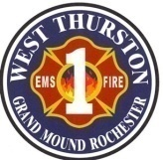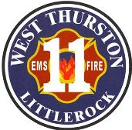
Thurston County Fire Protection Districts 1 & 11
West Thurston Regional Fire Authority
“Serving Better Together”
10828 Littlerock Rd SW
Olympia WA 98512
360.352.1614

Board of Fire Commissioners’ General Meeting

Monday, August 24, 2026, at 1730 hr.
ZOOM Meeting
Zoom virtual meeting link:
https://us02web.zoom.us/j/7583465513?pwd=MHdFQkR2Z3hPME1Dbm5Mekt5bkZMdz09&omn=81720506959
Meeting ID: 758 346 5513
Passcode: 54321

Call to Order

Attendance:

Additions/Deletions to Agenda:

- New Business (Action Items)

EXECUTIVE SESSION. THE PURPOSE OF THIS EXECUTIVE SESSION IS PURSUANT TO
RCW 42.30.110 (C) TO CONSIDER THE MINIMUM PRICE AT WHICH REAL ESTATE WILL BE OFFERED FOR SALE OR LEASE WHEN PUBLIC KNOWLEDGE REGARDING SUCH CONSIDERATION WOULD CAUSE A LIKELIHOOD OF DECREASED PRICE. HOWEVER, FINAL ACTION SELLING OR LEASING PUBLIC PROPERTY SHALL BE TAKEN IN A MEETING OPEN TO THE PUBLIC. THE DURATION OF THE EXECUTIVE SESSION IS SET AT 15 MINUTES BUT THIS MAY BE EXTENDED BY THE PRESIDING OFFICER. ACTION MAY OR MAY NOT BE TAKEN AFTER THE BOARD RECONVENES INTO REGULAR SESSION, AND NO ACTION SHALL BE TAKEN IN THE EXECUTIVE SESSION.

VIII Good of the Order:

IX Adjournment:

