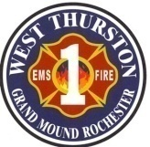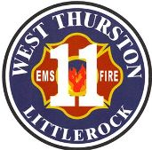
Thurston County Fire Protection Districts 1 & 11
West Thurston Regional Fire Authority
“Serving Better Together”
10828 Littlerock Rd SW
Olympia WA 98512
360.352.1614

Board of Fire Commissioners’ WORKSHOP

Monday, January 20, 2026, at 1730 hr.

In-Person: 10828 Littlerock Rd SW, Olympia
Zoom virtual meeting link:
https://us02web.zoom.us/j/83076618396?pwd=ozli9ZR3Ybu7FAhwbpK3XNLM8tAnFK.1
Meeting ID: 830 7661 8396
Passcode: 025261

Call to Order

Pledge of Allegiance

Attendance:

additions/deletions to agenda:

New business: Strategic Plan – Review/Feedback

old business:

XII Good of the Order:

XIII Adjournment:

