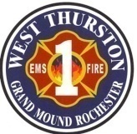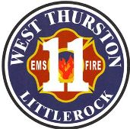
Thurston County Fire Protection Districts 1 & 11
West Thurston Regional Fire Authority
“Serving Better Together”
10828 Littlerock Rd SW
Olympia WA 98512
360.352.1614

Board of Fire Commissioners Workshop

Monday, October 27, 2025, at 1730 hr.

In-Person: 10828 Littlerock Rd SW, Olympia St. 1-2

Call to Order

Attendance:

Additions/Deletions to Agenda:

- New Business (Action Items): Budget workshop

- Good of the Order:

- Adjournment:

